

***My Target: ____ / 40 or ______ % Complete on the day of the test***

***🖒 🖓 (Circle when your test is handed back)***

**Name: __________________ Teacher: _______________**

**Task 3 –** In-Class Validation & Short Response **(History)**  **(7%)**

|  |  |
| --- | --- |
| ***Total Mark*** | ***%*** |
| ***/40*** |  |

**READING TIME – 5 Minutes WORKING TIME – 45 Minutes**

**(Part A) Multiple Choice (______/15 marks)**

1. Who was considered to be the ruler of all Ancient Greek Gods
2. Thor
3. Zeus
4. Poseidon
5. Jesus
6. Which person from Ancient Greek Mythology was said to have sleighed the monster Medusa
7. Perseus
8. Heracles
9. Hermes
10. Leonidas
11. Why are the shields significant to Ancient Greece
12. Protected its owner in battle but showed his allegiance to a particular city-state or leader
13. They were pretty.
14. They provided jobs for people.
15. People could use them to float on the water.
16. Which statement below accurately describes why the sea was of importance to the People of Ancient Greece
17. Ancient Greece was located on the Aegean Sea with a large coastline
18. Ancient Greece consisted of many different islands
19. Ancient Greece traded mainly grapes, olives and pottery with their own city states and other countries
20. All of the above
21. Which Greek God is the God of wine?
22. Dinosaur
23. Poseidon
24. Aphrodite
25. Dionysis
26. What is the name of the Battle where the Ancient Greeks defeated their enemy by hiding in a wooden horse.
27. Battle of Thermopylae
28. Trojan War
29. Battle of Marathon
30. Greco-Persian War.
31. What were the four main types of governments that ruled in the Ancient Greek City States
32. Monarchy, Democracy, Tyranny, Oligarchy
33. Democracy, Facism, Capitalism, Monarchy
34. Anarchy, Oligarchy, Dictatorship, Tyranny
35. Communism, Americanism, Monarchy, Dictatorship
36. What were the two main powerful city states of Ancient Greece
37. Athens and Olympia
38. Sparta and Athens
39. Sparta and Rome
40. Corinth and Olympia
41. What is the correct name that Ancient Greek soldiers were referred to
42. Unsullied
43. Norsemen
44. Hoplites
45. Hoplon

**10**. In descending order (top to bottom), what is the correct order for the Athenian social hierarchy.

a) Slaves, Metics, Freedman, Male Children, Citizens, Upper Class

b) Metics, Male Children, Upper Class, Slaves, Upper Class

c) Upper Class, Citizens, Male Children, Freedman/women, Slaves

Top

d) Male Children, Slaves, Metics, Upper-class, Freedmen/women, Slaves

Bottom

**11**. Who was considered a citizen in Athens?

1. Adult Males
2. Children
3. Adult Women
4. Queens

**12**. Which of the following best describes a city state in Ancient Greece?

1. A country town
2. A city that had the same government and currency as those around it.
3. The state of Western Australia
4. An independent city with its own government and currency

**13**. Which mythological creature in Ancient Greece had a hair of snakes and turned you into stone?

1. Perseus
2. Medusa
3. Minotaur
4. Persephone

**14.** According to Greek Mythology the home for the Gods was..?

1. Sparta
2. Mount Vesuvius
3. Troy
4. Mount Olympus

**15**. What were the two major crops grown in Ancient Greece?

1. Grapes and Olives
2. Grains and Gravel
3. Herbs and Flowers
4. Sheep and Clay

See next page

**(Part A) Short Answer Response (12 marks)**

1.With reference to a specific city state in Ancient Greece, **outline** what their Daily life would have consisted of. (4 marks)

Chosen City State: _________________________________________________________

2. **Describe** why religion was important to the Ancient Greeks and what their religion consisted of. (4 marks)

See next page

2. Label the following diagram of an Ancient Greek soldier using the specific Greek terms. (4 marks)

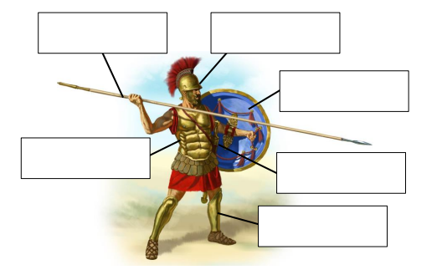

Pilos (Helmet)

Kopis (Sword)

See next page

**Part B: Validation** *A significant individual in an Ancient society*  **(13 marks)**

*Carefully read each task below and respond by using full sentences and correct grammar. Responses that provide detail, full explanations and examples, where required, will gain a greater amount of the marks offered. Ensure that you read the action words carefully and consider what action the task is intending you to take.*

1. State the name of the significant individual you studied. (1 mark)

___________

1. Outline your individual’s early life. (3 mark)

This task is asking you to consider;

* Where and when the individual was born
* Parents name
* Early influences on their life.

1. Describe the challenges your individual faced. (4 marks)

This task is asking you to consider;

1. *What issues/challenges did the individual face?*
2. *Were the issues/challenges that the individual faced presented by others?*
3. *Did the individual overcome these challenges? Why/why not?*

a) ____________________________________________________________________________ b) c) __________________________________________________________________ ______

4. Explain how your chosen individual is considered significant today. (5 marks)

*This task is asking you to consider;*

1. *What is your individual remembered for?*
2. *What short-term and long-term impacts did your individual have on society?*
3. *What is your individual’s legacy?*

a) b) c) ___________